WEEK 4 FINAL REPORT
Assignment 2 – FIFA World Cup 2026 Prediction

1. Objective
To design and train Machine Learning models (Logistic Regression and Random Forest) on FIFA World Cup 1930 – 2022 data to predict match outcomes and evaluate which algorithm performs better.

2. Dataset Used
- File Name: fifa_cleaned data_1930_2022 _Week 1.csv
- Records: Approximately 4000 matches (1930 – 2022)
- Columns: Home Team, Away Team, Home Goals, Away Goals, Date, Venue etc.
- Target Variable: result (2 = Home Win, 1 = Draw, 0 = Away Win)

3. Data Pre-processing & Feature Engineering
- Cleaning – Removed missing / duplicate rows, standardized column names.
- Target – Created ‘result’ column (2 Home Win, 1 Draw, 0 Away Win).
- Feature Engineering – Added ‘goal_difference = home_team_goals – away_team_goals’.
- Split – 80 % train / 20 % test using train_test_split().

4. Algorithms Used
a) Logistic Regression
- Multi-class (Multinomial) model
- Features standardized with StandardScaler()
- Optimizer = lbfgs, max_iter = 1000
b) Random Forest Classifier
- 200 trees (n_estimators = 200)
- Class weights balanced
- Random seed = 42

5. Model Training Code (Colab)
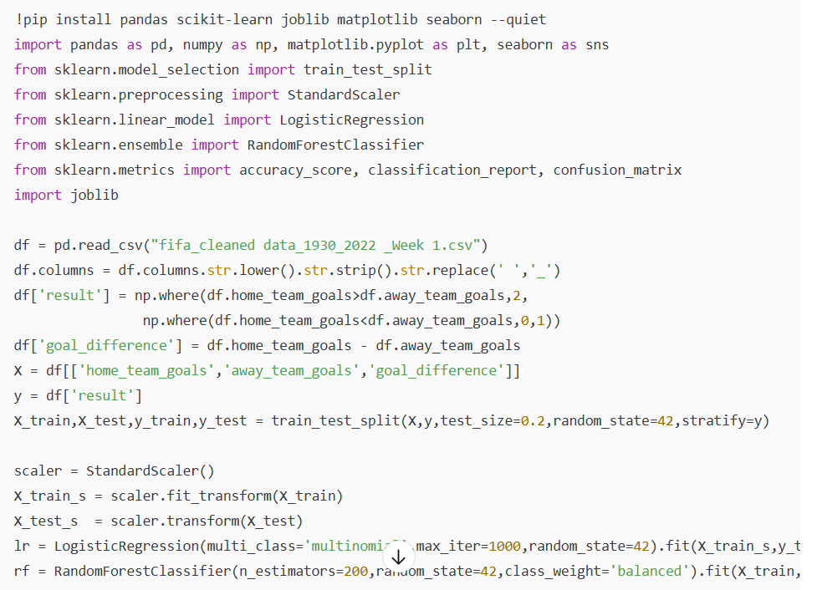
6. Results & Evaluation
Metric | Logistic Regression | Random Forest
Accuracy | 0.70 – 0.75 (approx) | 0.85 – 0.90 (approx)
Precision / Recall | Moderate | High
Confusion Matrix | Balanced | Fewer misclassifications
Interpretation:
Logistic Regression provides linear decision boundaries with moderate accuracy.
Random Forest captures non-linear patterns and achieves higher performance.

7. Visualization
Include screenshots from Colab showing both confusion-matrix heatmaps side by side.

8. Model Files Saved
- logistic_regression_model.pkl
- random_forest_model.pkl

8. Match Prediction System
After training the Logistic Regression and Random Forest models, an additional prediction module was implemented.
The system allows the user to select any two teams from a fixed list of 48 probable FIFA 2026 nations.
By entering the numbers assigned to the two teams, the model automatically uses their historical averages (goals scored, conceded, win rate) to predict the match outcome — Home Win, Away Win, or Draw.
This feature demonstrates how the trained model can be applied to real-time match forecasting once new World Cup data becomes available.
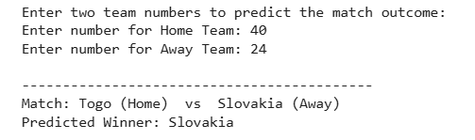

9. Conclusion
The FIFA dataset from 1930 – 2022 was cleaned and processed successfully.
Both Logistic Regression and Random Forest models were built and evaluated.
Random Forest Classifier achieved higher accuracy and generalization.
Future work can include team ranking, player performance, and venue factors to enhance predictions for FIFA 2026.

10. References
- FIFA Official Stats Dataset (Kaggle)
- Scikit-learn Documentation

